**Assignment 1**

**1. Camera Calibration**

I have taken images of a chessboard using Oak Camera from a distance of 44.4 inches in different positions and using these images in MatLab, I have performed camera calibration.

After calibrating the photos, we obtained the following parameters:

Finding the intrinsic and extrinsic parameters from the known 2D and 3D locations is known as calibration. The transformation of 3D coordinates to 2D coordinates depends on the rotation and translation matrices. The intrinsic parameter also includes the values for fx and fy.

**2. Real-world dimensions of an object**

I=imread('image1.jpg')

imshow(I)

[x,y]=ginput(2)

z=1412.6;

fy=1416.1;

fx=1426.5;

x1=z*(x(1)/fx);

x2=z*(x(2)/fx);

y1=z*(y(1)/fy);

y2=z*(y(2)/fy);

dist=sqrt((y2-y1)^2+(x2-x1)^2);

fprintf('The distqance is %.02f mm',dist);

**Output:**

**x =**

**326**

**492**

**y =**

**342.0000**

**230.0000**

**The distance is 198.76 mm>>**

Here, the anticipated value of 19.87 cm is about the same as the real side of the chessboard, which measures 19.5 cm, and the image used for calculation is:

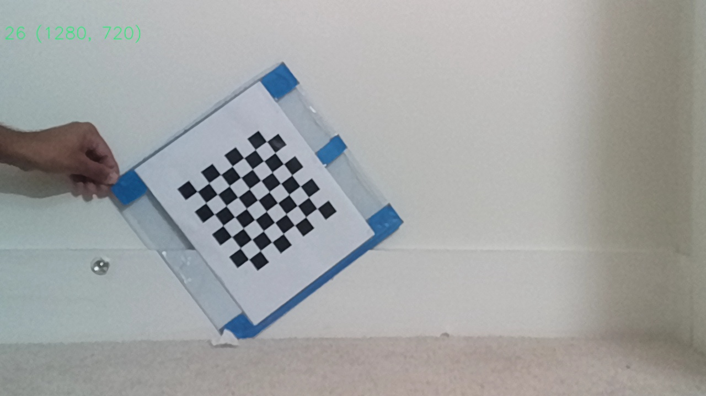

**3. RGB and Depth Map Stream**

We can get both the depth and RGB streams at the same time. The maximum framerate and resolution for the RGB stream are 32 and 720p, while the maximum framerate and resolution for the depth stream are 31 and 720p and, together, is 720p and 32fps.

RGB and Depth Stream

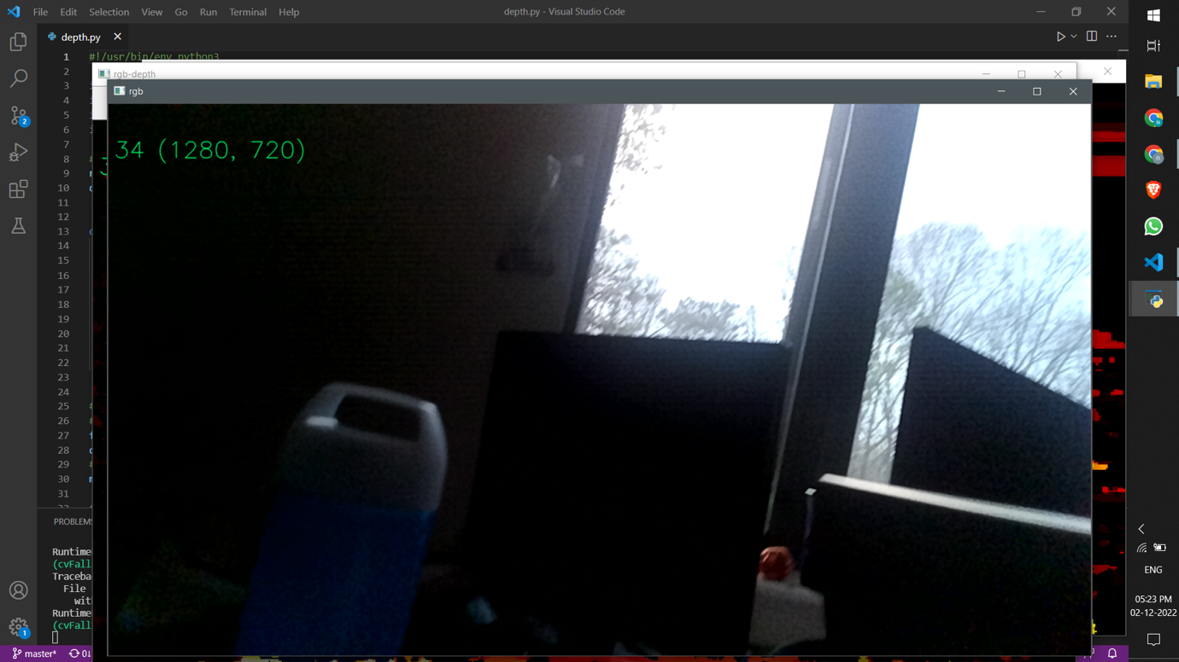

RGB Stream

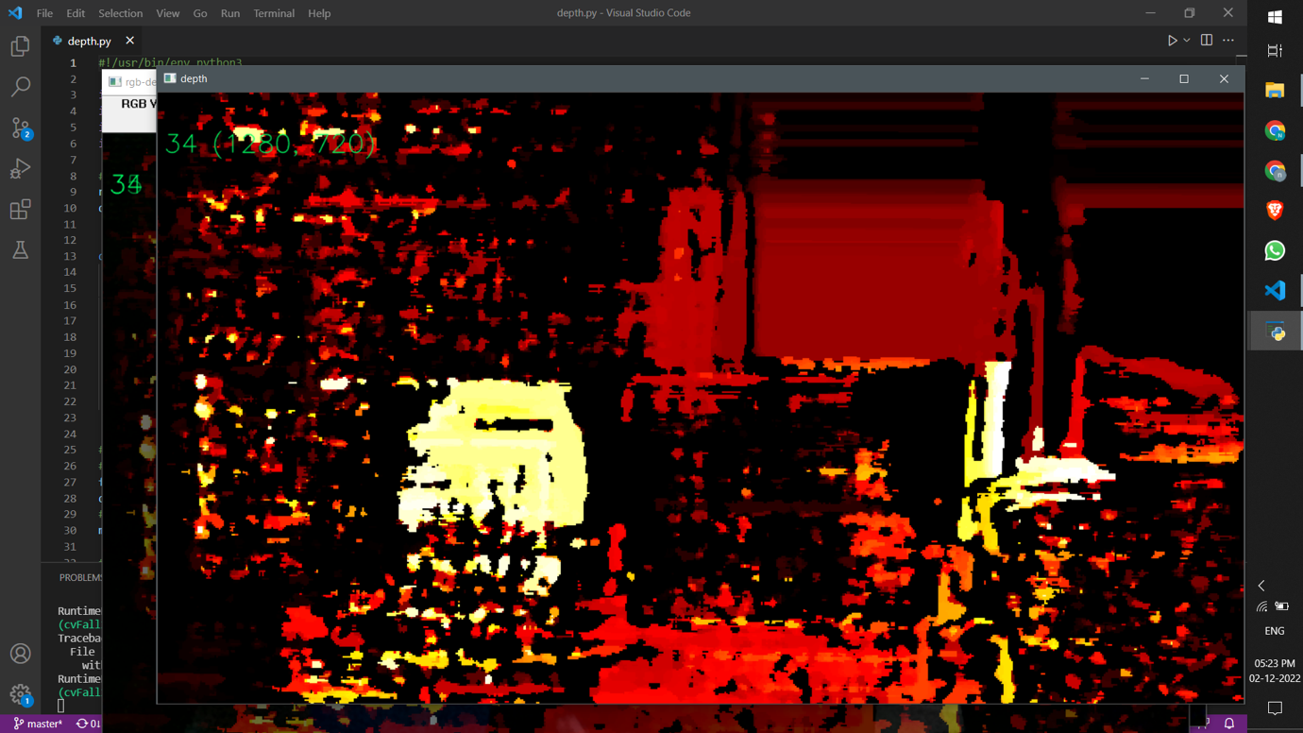

Depth Stream

Recordings Link:

<https://drive.google.com/drive/folders/1_ff9WK-SB15kc95kM_fc4xHKCuOwt6_H?usp=sharing>

GitHub Link: <https://github.com/MuraliRamRavipati/CVAssignments/tree/main/Assignment1>